A Minor Project Proposal Report on

“ Smart Student Management System ”

Submitted in Partial Fulfillment of the Requirements for the Degree of
Bachelors of Engineering in Information Technology
under Pokhara University

Submitted by:

Anamika Aryal, 231502 Dip Kiran Limbu, 231512 Sumit kumar Das, 231536 Suraj Kumar Jha, 2315537

Date:
4 Jun, 2026


Department of IT Engineering
NEPAL COLLEGE OF INFORMATION TECHNOLOGY
Balkumari Lalitpur, Nepal.

Educational institutions increasingly require digital solutions to efficiently manage aca-demic activities, monitor student performance, and maintain accurate records. Tradi-tional management approaches often involve manual attendance recording, fragmented communication channels, and limited access to academic analytics, leading to ineffi-ciencies in administrative and academic processes.
This project proposes the development of a Smart Academic Management System with AI-Based Attendance and Performance Analytics. The system will provide a centralized platform for managing academic activities through role-based access control for Super Admin, Department Admin, Teachers, and Students. Administrative function-alities include department, semester, course, teacher, and student management, along with institution-wide notice publication. Teachers will be able to manage attendance, assignments, internal assessments, notices, and performance evaluations. Students will have access to attendance records, academic progress statistics, assignment submissions, notices, and GPA-related insights.
A key feature of the system is the AI-powered attendance module, which utilizes YOLOv8-based face detection and facial recognition techniques to automate classroom attendance recording from captured images. Additionally, the system will provide performance an-alytics and GPA prediction features to support academic decision-making for both stu-dents and faculty members.
The proposed system will be developed using React.js with TypeScript for the frontend, FastAPI for backend services, PostgreSQL for data management, and WebSocket-based real-time communication. The expected outcome is a scalable, efficient, and intelligent academic management platform that improves administrative efficiency and enhances academic monitoring.
Keywords: Student Management System, Academic Management, YOLOv8, Facial Recognition, FastAPI, Performance Analytics, GPA Prediction, Role-Based Access Con-trol, WebSocket, Docker.

ABSTRACT i

- INTRODUCTION 1
  - Project Overview 1
  - Problem Statement 2
  - Project Objectives 3
  - Significance of the Study 3
  - Scope and Limitations 4
- LITERATURE REVIEW 5
  - Overview of Academic Management Systems 5
  - Traditional Attendance Management Approaches 5
  - Computer Vision-Based Attendance Systems 5
    - Traditional Computer Vision Techniques 5
    - Deep Learning Approaches 5
    - YOLOv8 for Classroom Face Detection 6
  - Research Gap and Proposed Contribution 6
- PROPOSED METHODOLOGY 7
  - System Architecture 7
  - Authentication and Authorization 8
  - Functional Modules 8
  - AI-Based Attendance Workflow 8
  - Database Design 10
  - Real-Time Communication 12
  - Deployment Strategy 12
- PROPOSED PERFORMANCE ANALYSIS METHODOLOGY AND VAL-IDATION SCHEME 13
  - Performance Analysis Methodology 13
    - System Performance Metrics 13
    - AI Attendance Performance Metrics 13
  - Validation Scheme 13
    - Functional Validation 13
    - Integration Validation 13
    - User Acceptance Testing 13
- PROPOSED DELIVERABLES/OUTPUT 14
  - Software Deliverables 14
  - Technical Deliverables 14
- PROJECT TASK AND TIME SCHEDULE 15
- TEAM MEMBERS AND DIVIDED ROLES 16
  - Shared Responsibilities 16

INTRODUCTION

Project Overview
Educational institutions manage a large volume of academic information, including stu-dent records, course allocations, attendance, assignments, notices, and performance evaluations. Traditional approaches often rely on multiple disconnected systems or man-ual processes, resulting in inefficiencies, data inconsistency, and increased administra-tive workload.
This project proposes the development of a Smart Academic Management System with AI-Based Attendance and Performance Analytics, a centralized web-based plat-form designed to streamline academic and administrative activities within an educational institution. The system will implement Role-Based Access Control (RBAC) to provide secure access to four user roles: Super Admin, Department Admin (HOD), Teacher, and Student.
The proposed system will enable academic administrators to manage departments, semesters, courses, teachers, and students efficiently. Teachers will be able to manage attendance, assignments, notices, and internal assessments, while students can access attendance records, assignment statuses, academic statistics, and GPA prediction insights.
A major feature of the project is the integration of artificial intelligence for attendance management. By using YOLOv8-based face detection and facial recognition techniques, the system will automate attendance recording from classroom images, reducing manual effort and improving accuracy. The system will also provide performance analytics and GPA prediction to help students and faculty make informed academic decisions.

Problem Statement
Many educational institutions still depend on manual or semi-digital processes for aca-demic management. Attendance is often recorded manually, notices are communicated through scattered channels, and student performance records are maintained in separate files or spreadsheets. These practices create several problems, including data duplica-tion, inaccurate attendance records, delayed communication, and limited visibility into student academic progress.
Manual attendance systems are time-consuming and vulnerable to proxy attendance. Teachers may spend valuable class time calling student names or checking attendance sheets. Similarly, administrators face difficulty maintaining updated records for depart-ments, semesters, courses, teachers, and students. Students often lack a single platform where they can check attendance, assignments, notices, internal marks, and academic progress.
There is therefore a need for an integrated academic management system that combines administration, attendance automation, assignment management, real-time communica-tion, performance analytics, and GPA prediction in a single secure platform.

Project Objectives

General Objective:
To develop a Smart Academic Management System that integrates academic administra-tion, AI-based attendance tracking, and student performance analytics into a centralized platform.

Specific Objectives:

- To implement a secure role-based access control system for Super Admin, De-partment Admin, Teachers, and Students.
- To manage departments, semesters, courses, teachers, and student enrollments through a centralized administration portal.
- To develop an AI-powered attendance system using YOLOv8-based face detection and facial recognition techniques.
- To provide assignment management and submission tracking functionalities.
- To automate internal marks management and academic record maintenance.
- To generate student performance analytics and academic progress reports.
- To provide GPA prediction and academic recommendation features for students.
- To implement real-time notifications and notice publishing using WebSocket com-munication.
- To provide an interactive dashboard for academic monitoring and decision-making.

Significance of the Study
The proposed system aims to improve the efficiency and effectiveness of academic man-agement processes within educational institutions. By centralizing academic informa-tion and automating routine administrative tasks, the system reduces manual workload and minimizes the possibility of errors.
The AI-based attendance module enhances attendance accuracy while reducing the time required for attendance recording. Performance analytics and GPA prediction features provide valuable insights into student progress, enabling teachers and administrators to identify academic trends and support students more effectively.
Students will benefit from transparent access to attendance records, assignment sta-tus, academic statistics, and performance predictions, allowing them to monitor their progress and make informed academic decisions.

Scope and Limitations

Scope:

- Role-based access control for Super Admin, Department Admin, Teachers, and Students.
- Department, semester, course, teacher, and student management.

- Course enrollment and assignment management.

- Notice publishing and real-time notifications.

- AI-based attendance tracking using classroom images.

- Internal marks management and performance evaluation.

- Student performance analytics and GPA prediction.

- Docker-based deployment architecture.

Limitations:

- The facial recognition module may be affected by lighting conditions, image qual-ity, and partial facial occlusions.
- Attendance recognition accuracy depends on the quality and quantity of training data available.
- The system will initially support local file storage rather than cloud-based storage solutions.
- GPA prediction results are estimations and should not be considered official aca-demic outcomes.

LITERATURE REVIEW

Overview of Academic Management Systems
Academic management systems have evolved significantly over the past decade, transi-tioning from simple record-keeping tools to comprehensive educational platforms. Sub-biah et al. [5] developed a web-based Student Database Management System that cen-tralized attendance, academic records, library information, and administrative functions. The system successfully replaced paper-based processes and improved data accessibil-ity.
Yu and Wang [4] introduced a student management system incorporating an optimized K-means clustering algorithm for intelligent student classification and performance anal-ysis. Their research demonstrated the value of data-driven academic insights for identi-fying student groups with similar academic characteristics.

Traditional Attendance Management Approaches
Traditional attendance management methods, including manual roll calls and sign-in sheets, have been widely criticized for inefficiency and inaccuracy. Roy et al. [9] stud-ied the implementation of automated attendance systems and identified key challenges including time consumption, susceptibility to proxy attendance, and difficulties in main-taining historical records.

Computer Vision-Based Attendance Systems

Traditional Computer Vision Techniques
Earlier automated attendance systems primarily relied on traditional computer vision techniques. Gomes et al. [3] developed a facial recognition attendance system using HAAR Cascade classifiers for face detection and Local Binary Pattern Histogram (LBPH) algorithms for recognition. The system successfully automated attendance recording but demonstrated recognition accuracy heavily dependent on image quality and lighting conditions.

Deep Learning Approaches
Recent studies have adopted deep learning approaches to overcome the limitations of traditional computer vision methods. Pratama et al. [2] developed a real-time atten-

dance system combining YOLOv8 for face detection and FaceNet for facial recognition, achieving an accuracy of 98.7%.
KLE Technological University [8] introduced a YOLOv8-enhanced one-shot learning attendance system that utilizes Siamese Networks, allowing student registration with only a single reference image while achieving approximately 97% recognition accuracy.

YOLOv8 for Classroom Face Detection
Ananda et al. [7] conducted a comprehensive evaluation of YOLOv8 for detecting low-resolution student faces in real classroom settings. Their findings demonstrated that larger YOLOv8 variants significantly improve detection accuracy while maintaining real-time detection speeds suitable for classroom applications.

Research Gap and Proposed Contribution
The reviewed literature indicates that existing solutions generally focus on either stu-dent management functionalities or attendance automation independently. Attendance systems primarily emphasize facial recognition accuracy, while student management systems concentrate on administrative data handling. Very few systems provide a uni-fied platform that combines role-based academic management, AI-powered attendance tracking, assignment management, real-time notifications, performance analytics, and GPA prediction within a single architecture.

PROPOSED METHODOLOGY

System Architecture
The proposed system will follow a Modular Monolith Architecture with an API-first design. The system consists of five major layers:
Table 3.1: System Architecture Layers

Layer | Technology | Purpose
Presentation Layer | React.js with  TypeScript | User interface with role-specific dash-  boards
Application Layer | FastAPI | Business logic, authentication, request  processing
Database Layer | PostgreSQL | Data storage and management
AI Attendance  Layer | YOLOv8 + Face  Recognition | Face detection and student identifica-  tion
Real-Time Layer | WebSockets | Notifications and real-time updates

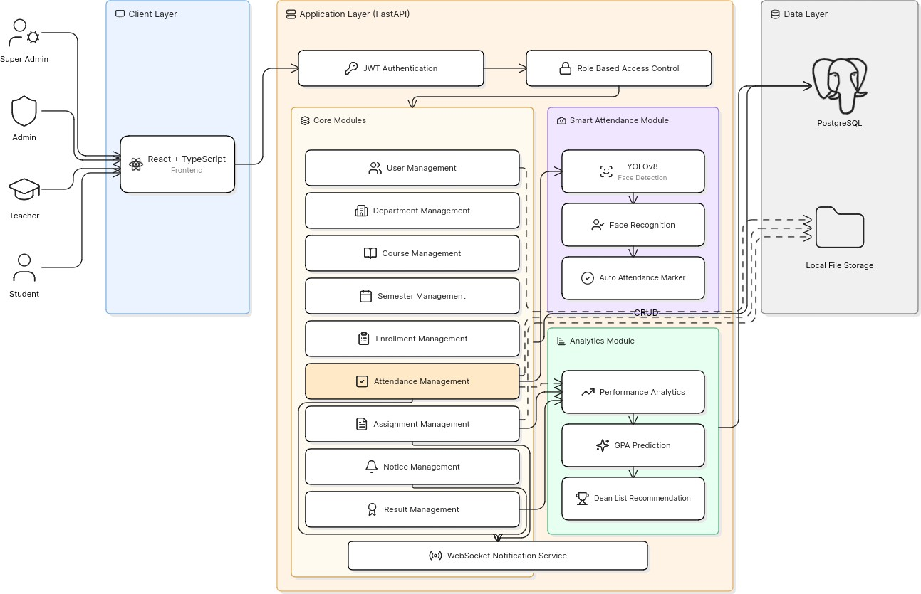
Figure 3.1: System Architecture Diagram

Authentication and Authorization
The system will implement JWT-based authentication and role-based authorization. Each user will be assigned a role that controls access to dashboards, APIs, and system fea-tures. Super Admin users will manage the overall institution, Department Admin users will manage department-level resources, Teachers will manage academic activities for assigned courses, and Students will access academic records and submissions.

Functional Modules

Table 3.2: Functional Modules

S.N. | Module | Description
1 | Super Admin Module | Institution management, departments,  semesters, users, notices
2 | Department Admin  Module | Department-level course, teacher, and student  management
3 | Teacher Module | Attendance, assignments, notices, internal  marks, evaluations
4 | Student Module | Attendance viewing, assignment submission,  notices, marks, GPA insights
5 | AI Attendance Module | Face detection, recognition, attendance con-  firmation, report generation
6 | Performance Analytics  Module | Attendance statistics, marks analysis,  progress visualization
7 | GPA Prediction Module | GPA estimation and academic recommenda-  tion support

AI-Based Attendance Workflow
The AI-based attendance module will automate attendance recording using image cap-ture and facial recognition. The proposed workflow is as follows:

- The teacher captures or uploads a classroom image for a specific course session.
- The backend sends the image to the AI attendance service.
- YOLOv8 detects student faces from the classroom image.
- Detected faces are cropped and passed to the facial recognition model.
- Recognized student identities are matched with enrolled students for the course.

- Attendance records are generated automatically and displayed to the teacher for verification.
- The teacher confirms or edits the generated attendance record.

- Final attendance data is stored in the PostgreSQL database.

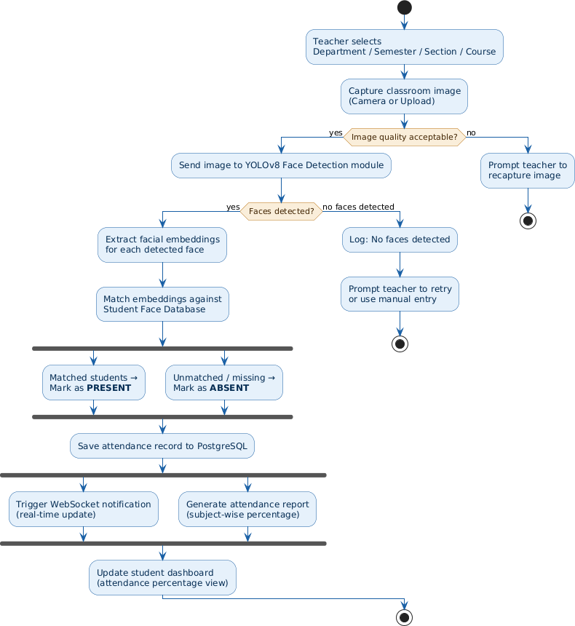

Figure 3.2: AI-Based Attendance Workflow

Database Design
The system database will be designed using PostgreSQL. Major entities include users, roles, departments, semesters, courses, enrollments, attendance, assignments, submis-sions, internal marks, notices, notifications, and GPA prediction records.
Table 3.3: Core Database Entities

Entity | Purpose
Users | Stores login and profile information for all system users
Roles | Defines Super Admin, Department Admin, Teacher, and  Student access levels
Departments | Stores academic department information
Courses | Stores course details and semester associations
Enrollments | Maps students to courses and semesters
Attendance | Stores attendance records for each course session
Assignments | Stores assignment details created by teachers
Submissions | Stores student assignment submissions and grading status
Internal Marks | Maintains assessment marks and evaluation records
Notices | Stores notices published by admins and teachers


Figure 3.3: Entity-Relationship Diagram

Real-Time Communication
WebSocket communication will be used to deliver real-time notices and notifications. When an admin or teacher publishes a notice, the backend will push the update to con-nected users according to their role, department, course, or enrollment group.

Deployment Strategy
The project will use Docker-based deployment. The frontend, backend, database, and supporting services will be configured through Dockerfiles and a docker-compose con-figuration. Nginx will be used as a reverse proxy for routing requests to frontend and backend services.

PROPOSED PERFORMANCE ANALYSIS METHODOL-OGY AND VALIDATION SCHEME

Performance Analysis Methodology

System Performance Metrics
System performance will be evaluated using response time, request throughput, database query efficiency, dashboard loading time, API error rate, and concurrent user handling capacity.

AI Attendance Performance Metrics
The AI attendance module will be evaluated using face detection accuracy, recognition accuracy, false acceptance rate, false rejection rate, processing time per image, and at-tendance generation time.

Validation Scheme

Functional Validation
Functional validation will verify that each module performs according to the specified re-quirements. Test cases will cover login, RBAC access, department management, course management, attendance recording, assignment submission, notice publishing, and re-port generation.

Integration Validation
Integration validation will ensure that frontend, backend, database, AI attendance ser-vice, and WebSocket notification features work together correctly. API responses, database updates, and real-time events will be tested across user roles.

User Acceptance Testing
User acceptance testing will involve administrators, teachers, and students. Feedback will be collected regarding usability, correctness, response time, and overall usefulness of the system.

PROPOSED DELIVERABLES/OUTPUT

Software Deliverables

Table 5.1: Software Deliverables

S.N. | Deliverable | Description
1 | Admin Management Mod-  ule | Department, semester, course, teacher,  and student management
2 | Teacher Module | Attendance, assignments, marks, no-  tices, and evaluations
3 | Student Module | Attendance records, assignment submis-  sions, notices, marks, and analytics
4 | AI Attendance Module | YOLOv8-based face detection and  recognition attendance automation
5 | Performance Analytics  Module | Statistics, reports, and visualizations
6 | GPA Prediction Module | GPA estimation and academic guidance
7 | Notice and Notification  Module | Real-time WebSocket communication

Technical Deliverables
- React.js Frontend Application (TypeScript-based)

- FastAPI Backend Services (Python)

- PostgreSQL Database Schema (SQL scripts)

- AI Attendance Model Integration (YOLOv8 weights and inference code)

- RESTful API Documentation (Swagger/OpenAPI)

- Docker Configuration Files (docker-compose.yml, Dockerfiles)

- Nginx Deployment Configuration

- Source Code Repository (Git)

PROJECT TASK AND TIME SCHEDULE

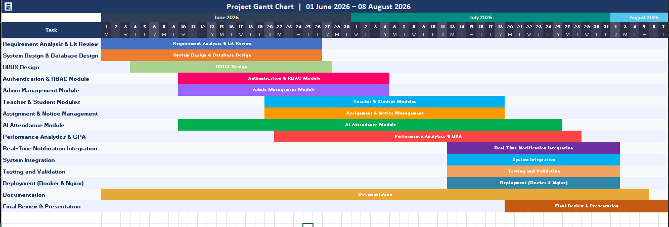
Figure 6.1: Project Development Timeline (Gantt Chart)

TEAM MEMBERS AND DIVIDED ROLES

Table 7.1: Team Member Responsibilities

S.N. | Member | Primary Responsibilities
1 | Member 1 | Project Lead, System Analysis, Backend API (FastAPI),  JWT/RBAC, Documentation
2 | Member 2 | Frontend Development (React.js, TypeScript), Dash-  board Design, UI/UX
3 | Member 3 | Database Design (PostgreSQL), Assignment Module,  Analytics & GPA Prediction
4 | Member 4 | AI Attendance Module (YOLOv8), WebSocket Integra-  tion, Docker Deployment

Shared Responsibilities
All team members will collaboratively contribute to requirement gathering, literature review, testing and debugging, report writing, presentations, deployment, and user ac-ceptance testing.

BIBLIOGRAPHY / REFERENCES

- Budi, H., et al. (2020). “IBAtS: Image Based Attendance System Using HAAR Cascade and LBPH.” International Journal of Advanced Computer Science and Applications, 11(3), pp. 45–52.
- Pratama, B., et al. (2024). “Real-Time Face Recognition Attendance System Using YOLOv8 and FaceNet.” Proceedings of ICCVAI 2024, pp. 112–120.
- Gomes, G., et al. (2019). “Class Attendance Management System Using Facial Recognition.” International Journal of Engineering Research and Technology, 8(6), pp. 234–241.
- Yu, Y., and Wang, W. (2022). “College Student Management System Based on K-Means Clustering.” Journal of Educational Information Technology, 15(4), pp. 78–89.
- Subbiah, R., et al. (2021). “Development of a Web-Based Student Database Man-agement System.” International Journal of Scientific Research in CSE, 9(2), pp. 34–42.
- Bucko, A., et al. (2021). “Enhancing JWT Authentication Based on User Behav-ior.” International Journal of Information Security, 15(3), pp. 56–71.
- Ananda, M., et al. (2024). “Enhancing Low-Resolution Facial Recognition Using YOLOv8.” Proceedings of ICAICV 2024, pp. 88–97.
- KLE Technological University. (2024). “YOLOv8-Enhanced One-Shot Learn-ing Attendance System.” International Journal of Computer Vision Applications, 12(1), pp. 23–35.
- Roy, S., et al. (2012). “Automated Attendance System Using Face Recognition.” NIT Agartala Technical Report, NITA-CS-2012-05.
- Ahmed, A., et al. (2024). “Fine-Tuning YOLOv8s for Crowded Face Detection.” International Journal of Computer Vision, 7(2), pp. 101–115.
- Smith, D., and Brown, J. (2024). “Modular Monoliths in Practice.” Software Ar-chitecture Journal, 18(1), pp. 45–59.
- Kumar, R., et al. (2024). “Face Recognition Using FaceNet and YOLOv8.” Inter-national Journal of AI Research, 9(1), pp. 67–82.

- Chen, L., et al. (2023). “Smart Attendance System Using Improved Facial Recog-nition.” Proceedings of ISA 2023, pp. 45–53.
- Smart Student Hub Team. (2024). “Smart Student Hub: Unified Academic Portal.” Journal of Web Engineering, 6(2), pp. 33–48.
- DMC College Research Group. (2023). “Automated Academic Record Manage-ment with BI.” International Journal of Educational IS, 11(4), pp. 56–70.
- Sharma, A. (2021). “Student Information System: Design Framework.” Interna-tional Journal of Information Management, 14(2), pp. 22–38.
- Patel, K., et al. (2023). “Student Management System Using Microservices.” In-ternational Journal of Cloud Computing, 8(3), pp. 44–58.
- Jocher, G., et al. (2023). “Ultralytics YOLOv8.” GitHub Repository, Ultralytics Inc.
- Schroff, F., et al. (2015). “FaceNet: A Unified Embedding for Face Recognition.” Proceedings of CVPR 2015, pp. 815–823.
- FastAPI Documentation. (2024). Available: https://fastapi.tiangolo.com/
- React Documentation. (2024). Available: https://react.dev/
- PostgreSQL Documentation. (2024). Available: https://www.postgresql. org/docs/
- Ultralytics Documentation. (2024). Available: https://docs.ultralytics. com/
- Docker Documentation. (2024). Available: https://docs.docker.com/
- Nginx Documentation. (2024). Available: https://nginx.org/en/docs/
- MDN WebSocket API. (2024). Available: https://developer.mozilla.org/ en-US/docs/Web/API/WebSockets_API
- TypeScript Documentation. (2024). Available: https://www.typescriptlang. org/docs/

